EXPERIMENT NO. 10
TOPIC: STUDY OF ENVIRONMENTAL LAWS AND ACTS
1. Indian Forest Act, 1927
- Objective: To regulate forest management, conserve forest resources, and control trade in forest produce.
- Key Features:
- Classifies forests into Reserved Forests, Protected Forests, and Village Forests.
- Restricts cutting of trees, hunting, and collection of forest produce without permission.
- Allows the government to declare any forest area as protected.
- Importance: Foundation for forest conservation laws in India.
2. Wildlife Protection Act, 1972
- Objective: To protect endangered species of plants and animals and create protected areas.
- Key Features:
- Provides for the establishment of Wildlife Sanctuaries, National Parks, and Biosphere Reserves.
- Regulates hunting of wild animals; schedules species into categories with varying protection levels.
- Creates a Wildlife Crime Control Bureau.
- Importance: Prevents poaching, illegal trade in wildlife, and loss of biodiversity.
3. Water (Prevention and Control of Pollution) Act, 1974
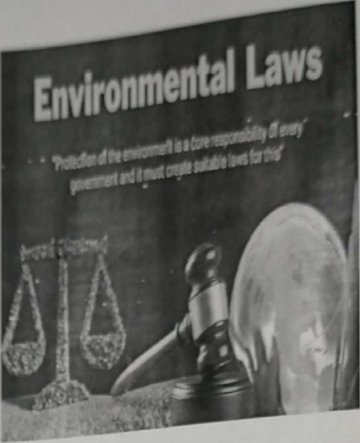
- Objective: To prevent and control water pollution and maintain water quality.
- Key Features:
- Establishes Central Pollution Control Board (CPCB) and State Pollution Control Boards (SPCBs).
- Sets standards for water quality and effluent discharge.
- Requires industries to obtain permission before discharging pollutants.
- Importance: First major law addressing pollution control in India.
4. Air (Prevention and Control of Pollution) Act, 1981
- Objective: To control air pollution and improve air quality.
- Key Features:
- Expands the powers of CPCB and SPCBs to regulate emissions from industries and vehicles.
- Declares certain areas as Air Pollution Control Areas.
- Mandates the use of pollution-control equipment.
- Importance: Helps reduce industrial and vehicular emissions.
5. Environment (Protection) Act, 1986
- Objective: To provide a framework for the protection and improvement of the environment.
- Reason for Enactment: Passed after the Bhopal Gas Tragedy (1984) to strengthen environmental regulations.
- Key Features:
- Empowers the Central Government to take measures to protect the environment.
- Regulates industrial activities and hazardous waste management.
- Covers air, water, and land pollution under one umbrella law.
- Importance: Called the “umbrella act” because it supplements other pollution control laws.
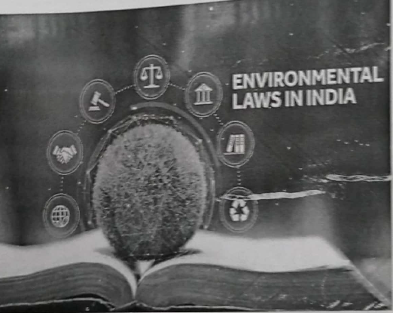
6. Public Liability Insurance Act, 1991
- Objective: To provide immediate relief to persons affected by accidents involving hazardous substances.
- Key Features:
- Requires owners handling hazardous substances to take insurance policies.
- Compensation to victims without needing to prove fault (no-fault liability).
- Importance: Protects citizens from industrial accidents like chemical leaks.
7. National Green Tribunal (NGT) Act, 2010
- Objective: To establish a specialized tribunal for speedy disposal of environmental disputes.
- Key Features:
- Deals with cases related to environmental protection, conservation of forests, and natural resources.
- Can order compensation for environmental damage.
- Decisions are binding like those of a civil court.
- Importance: Reduces burden on regular courts and ensures quicker resolution of environmental cases.
TERNA ENGINEERING COLLEGE, NERUL
TITLE | CASE STUDY ON ENVIRONMENTAL LAWS AND ACTS
NAME | Avdhut Parish Madhavi
CLASS / BATCH | COMP / SEM III / C2 | ROLL NO. C-60
SIGN

